**EXERCISE 1: MOCKING AND STUBBING**

CONTEXT OF THE EXAMPLE:

This example simulates a service (MyService) that relies on an external API (ExternalApi). Using Mockito, we verify that the service correctly interacts with the external API by calling its getData() method during execution.

CODES:

pom.xml

<?xml version="1.0" encoding="UTF-8"?>  
<project xmlns="http://maven.apache.org/POM/4.0.0"  
 xmlns:xsi="http://www.w3.org/2001/XMLSchema-instance"  
 xsi:schemaLocation="http://maven.apache.org/POM/4.0.0 http://maven.apache.org/xsd/maven-4.0.0.xsd">  
 <modelVersion>4.0.0</modelVersion>  
  
 <groupId>com.dinesh</groupId>  
 <artifactId>Mockito_1</artifactId>  
 <version>1.0-SNAPSHOT</version>  
  
 <properties>  
 <maven.compiler.source>20</maven.compiler.source>  
 <maven.compiler.target>20</maven.compiler.target>  
 <project.build.sourceEncoding>UTF-8</project.build.sourceEncoding>  
 </properties>  
 <dependencies>  
 <!-- JUnit 5 -->  
 <dependency>  
 <groupId>org.junit.jupiter</groupId>  
 <artifactId>junit-jupiter-api</artifactId>  
 <version>5.10.0</version>  
 <scope>test</scope>  
 </dependency>  
  
 <!-- JUnit 5 Engine -->  
 <dependency>  
 <groupId>org.junit.jupiter</groupId>  
 <artifactId>junit-jupiter-engine</artifactId>  
 <version>5.10.0</version>  
 <scope>test</scope>  
 </dependency>  
  
 <!-- Mockito -->  
 <dependency>  
 <groupId>org.mockito</groupId>  
 <artifactId>mockito-core</artifactId>  
 <version>5.12.0</version>  
 <scope>test</scope>  
 </dependency>  
 </dependencies>  
  
</project>

MyServicetest.java

package com.dinesh;  
  
import org.junit.jupiter.api.Test;  
import static org.junit.jupiter.api.Assertions.*assertEquals*;  
import static org.mockito.Mockito.*;  
  
public class MyServicetest {  
  
 @Test  
 public void testExternalApi() {  
 // Arrange: Create mock and stub the method  
 ExternalApi mockApi = *mock*(ExternalApi.class);  
 *when*(mockApi.getData()).thenReturn("Mock Data");  
  
 // Act: Inject mock into service and call method  
 MyService service = new MyService(mockApi);  
 String result = service.fetchData();  
  
 // Assert: Validate the expected result  
 *assertEquals*("Mock Data", result);  
 }  
}

ExternalApi.java

package com.dinesh;  
  
public interface ExternalApi {  
 String getData();  
}

MyService.java

package com.dinesh;  
  
public class MyService {  
 private ExternalApi externalApi;  
  
 public MyService(ExternalApi externalApi) {  
 this.externalApi = externalApi;  
 }  
  
 public String fetchData() {  
 return externalApi.getData();  
 }  
}

OUTPUT:

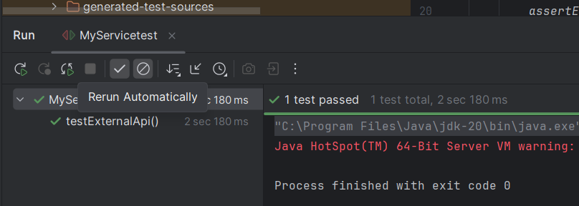

**EXERCISE 2: VERIFYING INTERACTIONS**

CONTEXT OF THE EXAMPLE:

In this example, a service class (MyService) depends on an external API (ExternalApi). The goal is to verify that the getData() method from the external API is actually called when the service's fetchData() method is executed. Mockito helps ensure this interaction happens as expected.

CODES:

pom.xml

<?xml version="1.0" encoding="UTF-8"?>  
<project xmlns="http://maven.apache.org/POM/4.0.0"  
 xmlns:xsi="http://www.w3.org/2001/XMLSchema-instance"  
 xsi:schemaLocation="http://maven.apache.org/POM/4.0.0 http://maven.apache.org/xsd/maven-4.0.0.xsd">  
 <modelVersion>4.0.0</modelVersion>  
  
 <groupId>com.dinesh</groupId>  
 <artifactId>Mockito_1</artifactId>  
 <version>1.0-SNAPSHOT</version>  
  
 <properties>  
 <maven.compiler.source>20</maven.compiler.source>  
 <maven.compiler.target>20</maven.compiler.target>  
 <project.build.sourceEncoding>UTF-8</project.build.sourceEncoding>  
 </properties>  
 <dependencies>  
 <!-- JUnit 5 -->  
 <dependency>  
 <groupId>org.junit.jupiter</groupId>  
 <artifactId>junit-jupiter-api</artifactId>  
 <version>5.10.0</version>  
 <scope>test</scope>  
 </dependency>  
  
 <!-- JUnit 5 Engine -->  
 <dependency>  
 <groupId>org.junit.jupiter</groupId>  
 <artifactId>junit-jupiter-engine</artifactId>  
 <version>5.10.0</version>  
 <scope>test</scope>  
 </dependency>  
  
 <!-- Mockito -->  
 <dependency>  
 <groupId>org.mockito</groupId>  
 <artifactId>mockito-core</artifactId>  
 <version>5.12.0</version>  
 <scope>test</scope>  
 </dependency>  
 </dependencies>  
  
</project>

ExternalApi.java

package com.dinesh;  
  
public interface ExternalApi {  
 String getData();  
}

MyServicetest.java

package com.dinesh;  
  
import org.junit.jupiter.api.Test;  
import static org.mockito.Mockito.*;  
  
public class MyServicetest {  
  
 @Test  
 public void testVerifyInteraction() {  
 ExternalApi mockApi = *mock*(ExternalApi.class);  
 MyService service = new MyService(mockApi);  
 service.fetchData();  
 *verify*(mockApi).getData();  
 }  
}

MyService.java

package com.dinesh;  
public class MyService {  
 private ExternalApi externalApi;  
  
 public MyService(ExternalApi externalApi) {  
 this.externalApi = externalApi;  
 }  
  
 public String fetchData() {  
 return externalApi.getData();  
 }  
}

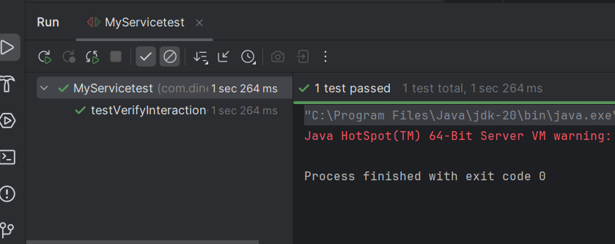OUTPUT: